**Unidade de análise**

Equipes que participaram da temporada regular da NBA de 2006 à 2016.

**Tamanho da amostra**

330 observações.

**Fonte de dados**

<http://stats.nba.com/>

**Problema de pesquisa**

Quais fatores influenciam no percentual de vitória de uma equipe na temporada regular da NBA?

**Variáveis do modelo**

* **Variável dependente:**
  + Percentual de vitórias na temporada regular (win_percentage).
* **Variáveis independentes:**
  + Percentual efetivo dos pontos de quadra (effective_field_goal_percentage)
  + Taxa de conversão dos lances livres (free_throw_attempt_rate)
  + Percentual de erros por posse de bola (turnover_percentage)
  + Percentual de rebotes ofensivos (offensive_rebound_percentage)
  + Percentual efetivo dos pontos de quadra dos adversários (opponent_effective_field_goal_percentage)
  + Taxa de conversão dos lances livres dos adversários (opponent_free_throw_attempted_rate)
  + Percentual de erros por posse de bola dos adversários (opponent_turnover_percentage)
  + Percentual de rebotes ofensivos dos adversários (opponent_offensive_rebound_rate)

**Estatística descritiva do percentual de vitória**

* **Mínimo:** 0.10.
* **Percentil 25 (primeiro quartil):** 0.39.
* **Percentil 50 (mediana):** 0.503.
* **Média:** 0.500.
* **Percentil 75 (terceiro quartil):** 0.621.
* **Máximo:** 0.89.

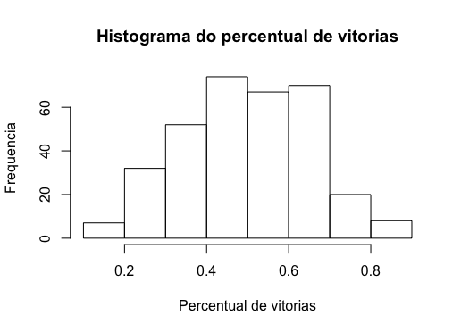

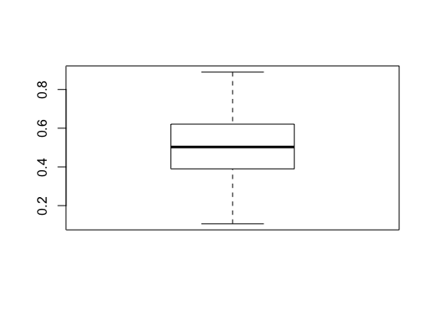

**<Evolução da mediana do percentual de vitórias ao longo dos anos>**

**Análise exploratória entre a variável dependente e as variáveis independentes**

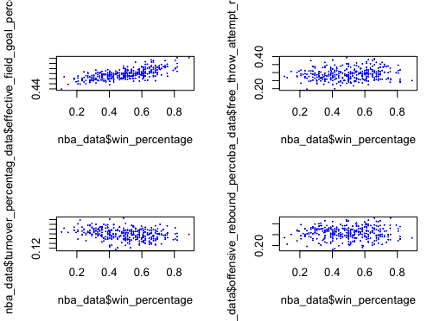

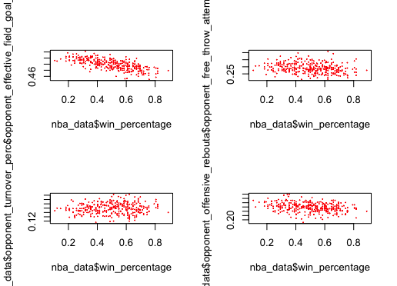

**Resultados da regressão linear múltipla**

Call:

lm(formula = nba_data$win_percentage ~ nba_data$effective_field_goal_percentage +

nba_data$free_throw_attempt_rate + nba_data$turnover_percentage +

nba_data$offensive_rebound_percentage + nba_data$opponent_effective_field_goal_percentage +

nba_data$opponent_free_throw_attempted_rate + nba_data$opponent_turnover_percentage +

nba_data$opponent_offensive_rebound_rate)

Residuals:

Min 1Q Median 3Q Max

-0.163983 -0.026007 -0.001716 0.029618 0.124175

Coefficients:

Estimate Std. Error t value Pr(>|t|)

(Intercept) 0.69334 0.12127 5.717 2.48e-08 ***

nba_data$effective_field_goal_percentage 4.47496 0.13177 33.962 < 2e-16 ***

nba_data$free_throw_attempt_rate 0.54908 0.07779 7.059 1.04e-11 ***

nba_data$turnover_percentage -4.24910 0.24070 -17.653 < 2e-16 ***

nba_data$offensive_rebound_percentage 1.59817 0.09981 16.012 < 2e-16 ***

nba_data$opponent_effective_field_goal_percentage -4.70858 0.14458 -32.568 < 2e-16 ***

nba_data$opponent_free_throw_attempted_rate -0.67640 0.07874 -8.590 3.84e-16 ***

nba_data$opponent_turnover_percentage 3.28387 0.22555 14.559 < 2e-16 ***

nba_data$opponent_offensive_rebound_rate -1.19539 0.13158 -9.085 < 2e-16 ***

---

Signif. codes: 0 '***' 0.001 '**' 0.01 '*' 0.05 '.' 0.1 ' ' 1

Residual standard error: 0.04159 on 321 degrees of freedom

Multiple R-squared: 0.9305, Adjusted R-squared: 0.9288

F-statistic: 537.3 on 8 and 321 DF, p-value: < 2.2e-16

**Significância da correlação entre as variáveis (análise de variância)**

Response: nba_data$win_percentage

Df Sum Sq Mean Sq F value Pr(>F)

nba_data$effective_field_goal_percentage 1 3.6675 3.6675 2120.591 < 2.2e-16 ***

nba_data$free_throw_attempt_rate 1 0.0477 0.0477 27.575 2.756e-07 ***

nba_data$turnover_percentage 1 0.3038 0.3038 175.681 < 2.2e-16 ***

nba_data$offensive_rebound_percentage 1 0.6762 0.6762 390.998 < 2.2e-16 ***

nba_data$opponent_effective_field_goal_percentage 1 2.2857 2.2857 1321.575 < 2.2e-16 ***

nba_data$opponent_free_throw_attempted_rate 1 0.0585 0.0585 33.802 1.473e-08 ***

nba_data$opponent_turnover_percentage 1 0.2520 0.2520 145.691 < 2.2e-16 ***

nba_data$opponent_offensive_rebound_rate 1 0.1428 0.1428 82.539 < 2.2e-16 ***

Residuals 321 0.5552 0.0017

---

Signif. codes: 0 '***' 0.001 '**' 0.01 '*' 0.05 '.' 0.1 ' ' 1

**Pressupostos - Teste de distribuição normal dos erros (resíduos)**

Shapiro-Wilk normality test

data: residuals(regressao)

W = 0.99425, p-value = 0.2487

**Pressupostos - Validação da variância constante dos erros**

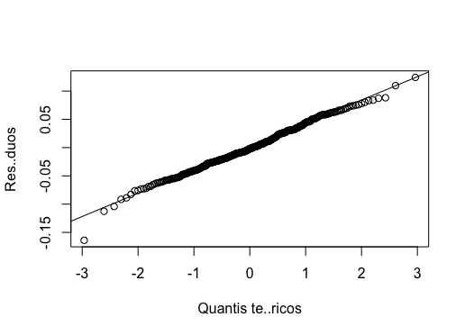

F test to compare two variances

data: residuals(regressao)[nba_data$effective_field_goal_percentage <= and residuals(regressao)[nba_data$effective_field_goal_percentage >= 0.498] and 0.498]

F = 1.1663, num df = 167, denom df = 168, p-value = 0.3203

alternative hypothesis: true ratio of variances is not equal to 1

95 percent confidence interval:

0.8607217 1.5806647

sample estimates:

ratio of variances

1.166329

data: residuals(regressao)[nba_data$free_throw_attempt_rate <= 0.2885] and residuals(regressao)[nba_data$free_throw_attempt_rate >= 0.2885]

F = 1.0655, num df = 164, denom df = 164, p-value = 0.6852

alternative hypothesis: true ratio of variances is not equal to 1

95 percent confidence interval:

0.7836905 1.4485775

sample estimates:

ratio of variances

1.065475

data: residuals(regressao)[nba_data$turnover_percentage <= 0.1495] and residuals(regressao)[nba_data$turnover_percentage >= 0.1495]

F = 1.0773, num df = 164, denom df = 164, p-value = 0.634

alternative hypothesis: true ratio of variances is not equal to 1

95 percent confidence interval:

0.7924041 1.4646837

sample estimates:

ratio of variances

1.077321

data: residuals(regressao)[nba_data$offensive_rebound_percentage <= and residuals(regressao)[nba_data$offensive_rebound_percentage >= 0.2595] and 0.2595]

F = 1.0378, num df = 164, denom df = 164, p-value = 0.8126

alternative hypothesis: true ratio of variances is not equal to 1

95 percent confidence interval:

0.7633134 1.4109123

sample estimates:

ratio of variances

1.037771

data: residuals(regressao)[nba_data$opponent_effective_field_goal_percentage <= and residuals(regressao)[nba_data$opponent_effective_field_goal_percentage >= 0.5] and 0.5]

F = 1.1338, num df = 168, denom df = 168, p-value = 0.4165

alternative hypothesis: true ratio of variances is not equal to 1

95 percent confidence interval:

0.837063 1.535812

sample estimates:

ratio of variances

1.133831

data: residuals(regressao)[nba_data$opponent_free_throw_attempted_rate <= and residuals(regressao)[nba_data$opponent_free_throw_attempted_rate >= 0.286] and 0.286]

F = 1.1124, num df = 165, denom df = 168, p-value = 0.4922

alternative hypothesis: true ratio of variances is not equal to 1

95 percent confidence interval:

0.820307 1.509246

sample estimates:

ratio of variances

1.112439

data: residuals(regressao)[nba_data$opponent_turnover_percentage <= and residuals(regressao)[nba_data$opponent_turnover_percentage >= 0.149] and 0.149]

F = 0.91812, num df = 165, denom df = 176, p-value = 0.5791

alternative hypothesis: true ratio of variances is not equal to 1

95 percent confidence interval:

0.6797338 1.2419500

sample estimates:

ratio of variances

0.9181198

data: residuals(regressao)[nba_data$opponent_offensive_rebound_rate <= and residuals(regressao)[nba_data$opponent_offensive_rebound_rate >= 0.259] and 0.259]

F = 1.3099, num df = 167, denom df = 165, p-value = 0.08307

alternative hypothesis: true ratio of variances is not equal to 1

95 percent confidence interval:

0.9651542 1.7773605

sample estimates:

ratio of variances

1.309929